**How to Create Snowflake account**

1. **Visit Snowflake's Official Website**

Navigate to Snowflake's official website: https://www.snowflake.com

1. **Click on the "Start for Free" Button**



1. **Complete the Sign-Up Form**

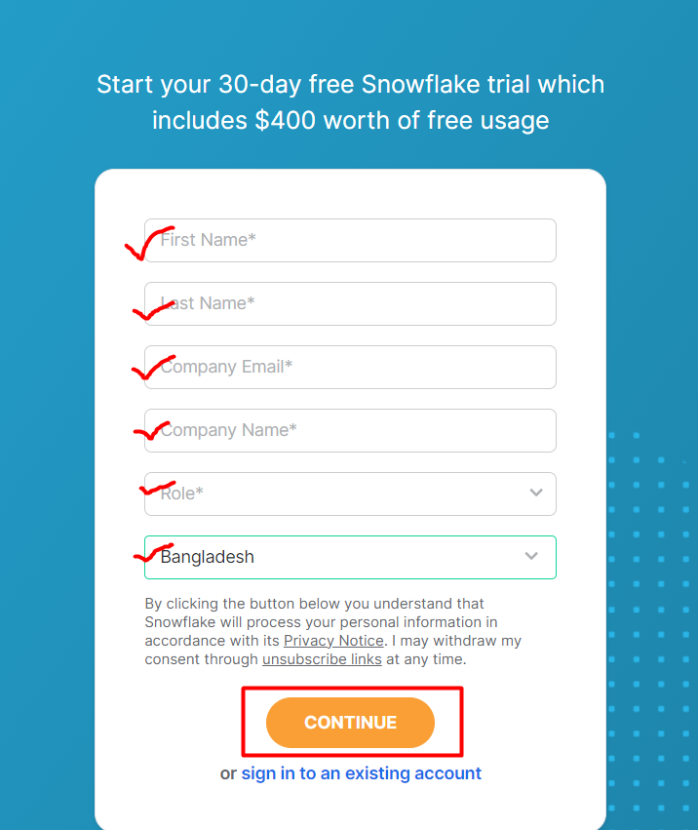

You will be directed to a registration form. Fill out the necessary details such as:

First Name

Last Name

Email Address

Company Name

Password

Country or Region

1. **Verification**

After completing the sign-up form, Snowflake will send you an email to verify your email address. Open your email, locate the verification email from Snowflake, and click on the verification link.

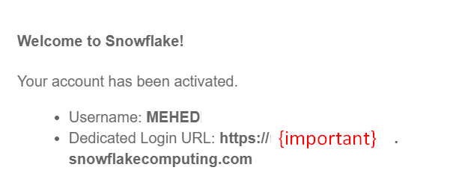

1. Go to your snowflake account to create database

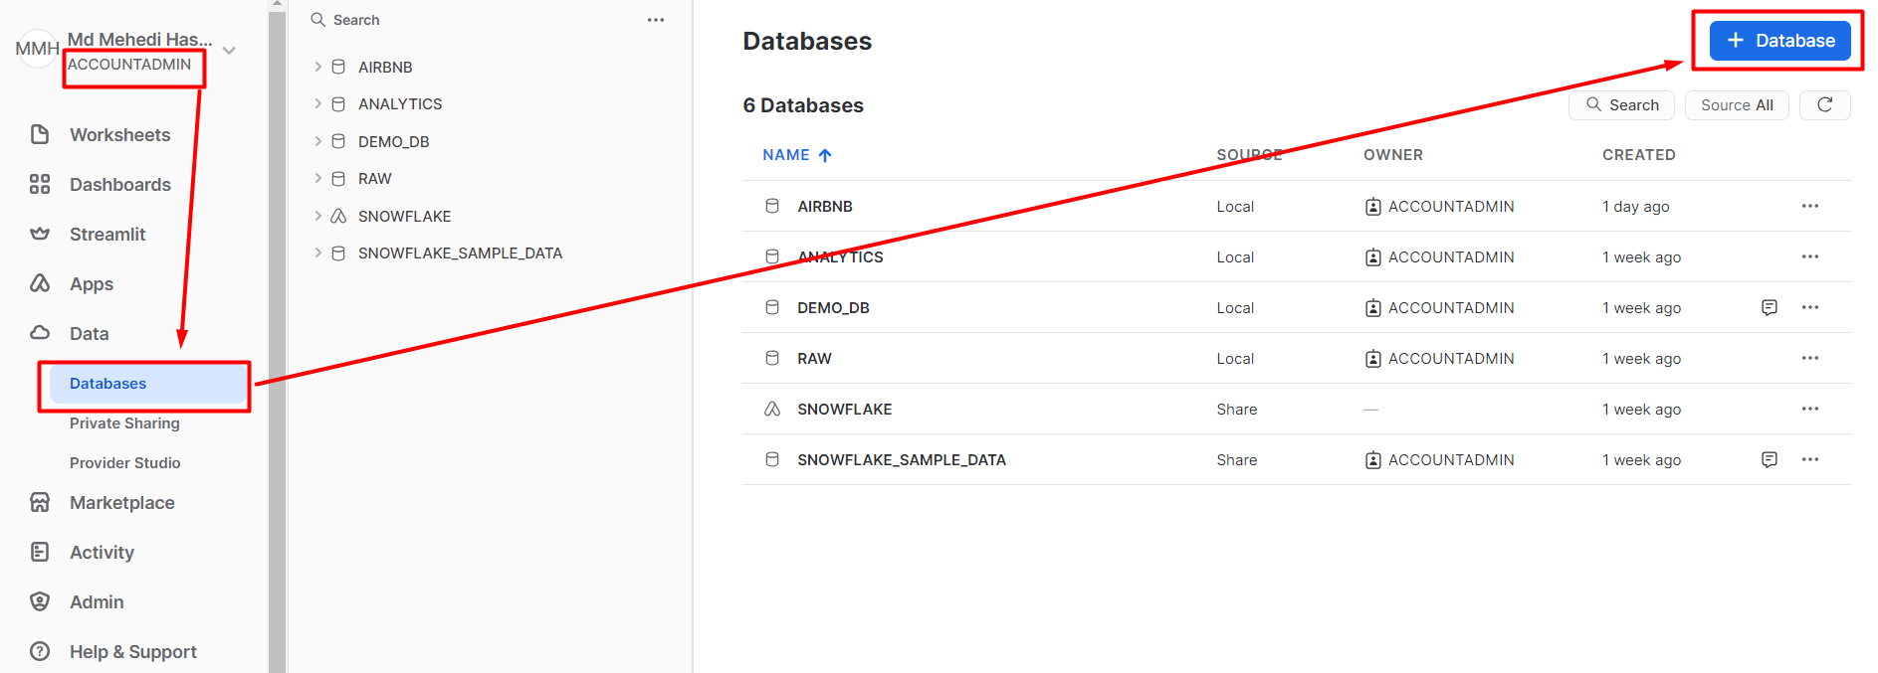

1. Create demo_db database in your snowflake account

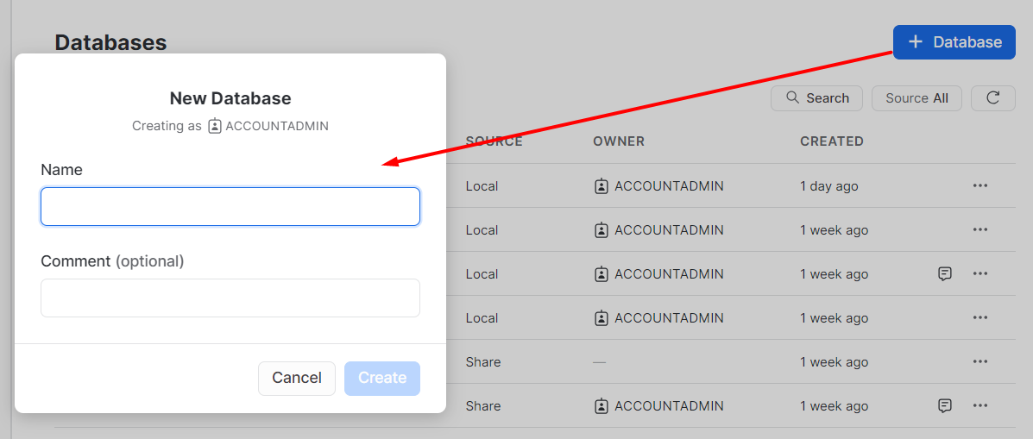

**How to install dbt?**

1. Install git in your system : https://git-scm.com/
2. install python 3.8 {check all tick mark}
3. Create a folder on PC
4. Open this folder by cmd
5. create a virtual env by python Using following command.

virtualenv venv

1. activate venv

venv\Scripts\activate

1. Install dbt and dbt-snowflake

pip install dbt-core dbt-snowflake

1. Check dbt version

dbt –version

**Setting profile.yml file:**

1. **Go to local disk C**
2. **click user**
3. **Go to pc username folder**
4. **Click .dbt**
5. **Separate profile.yml (if it exist of previous any project) file to another folder.**

**Create Dbt Project:**

1. dbt init demo_dbt
2. Provide information from snowflake
3. Desired authentication type option (enter a number): 1
4. Account: {go to mail copy and pest the {important} }
5. User: {snowflake username}
6. password (dev password): {your dbt password}
7. role (dev role): ACCOUNTADMIN
8. warehouse (warehouse name): COMPUTE_WH
9. database (default database that dbt will build objects in): demo_db
10. schema (default schema that dbt will build objects in): PUBLIC
11. threads (1 or more) [1]: 10
12. Go to CMD
13. Go to project folder by cd : example cd demo_dbt
14. Run: dbt debug
15. If output is all checks passed!
16. Run: dbt run
17. Visit Snowflake view your database to see dbt output.